**FLIR Announces Business and Technology Partnership with UE Systems for Acoustic Imaging Condition Monitoring and Energy Conservation**

*Agreement Enables UE Systems and FLIR to Scale Ultrasonic Imaging Solutions for Manufacturing, Utility, and Processing Industries*

**HUDSON, N.H., & Elmsford, N.Y. – May 13, 2024 –** [FLIR](https://www.flir.com/), part of Teledyne Technologies, and [UE Systems](https://www.uesystems.com/), a world leader in ultrasound inspection tools, today announced a business and technology partnership to provide industrial customers with leading-edge predictive maintenance solutions, beginning with the FLIR Si2-Series of acoustic imaging cameras: [Si2-Pro](https://www.flir.com/products/si2-pro/), [Si2-LD](https://www.flir.com/products/si2-ld/), and [Si2-PD](https://www.flir.com/products/si2-pd/).

Leveraging each organization’s deep expertise in supporting manufacturing reliability and energy conservation, UE Systems and FLIR will jointly operate throughout the world providing ultrasonic technology for condition monitoring needs over a wide range of industrial applications. The Si2-series empowers customers to pinpoint issues relating to detecting partial discharge, identifying pressurized leaks, and locating mechanical faults in industrial environments.

“By partnering together, FLIR and UE Systems can provide manufacturing-focused industrial customers with more effective acoustic imaging solutions and expertise as part of comprehensive condition monitoring, predictive maintenance, and energy conservation programs,” said Mark Bochella, Vice President of Sales and Marketing, FLIR. “The mutually beneficial combination of FLIR’s strong brand, built on its thermal imaging expertise, with UE Systems’ extensive understanding of ultrasonic maintenance programs within manufacturing environments presents an enticing growth opportunity for both organizations.”

“This partnership affords FLIR and UE Systems the ability to combine their respective strengths for the benefit of reliability maintenance programs and energy conservation across the world, starting with the Si2-Series of acoustic imaging cameras,” said Blair Fraser, Vice President, Global Technology & Business Development, UE Systems. “In the months and years ahead, we anticipate UE Systems and FLIR will explore additional opportunities for collaboration that provide comprehensive, multi-sensing solutions customers can’t find anywhere else.”

The technology and business partnership initially comprises the Si2-Series of acoustic imaging cameras, offering industrial-grade solutions that address the top inspection requirements for manufacturing, electrical, processing, and utilities organizations. The partnership also opens additional opportunities for FLIR and UE Systems to collaborate on future industrial maintenance initiatives that align with the respective priorities of each organization.

For more information about FLIR acoustic imaging capabilities, visit <https://www.flir.com/browse/industrial/acoustic-imaging-cameras/>. For more about UE Systems ultrasonic solutions, visit <https://www.uesystems.com/ultrasound-technology/>.

###

**ABOUT FLIR, A TELEDYNE TECHNOLOGIES COMPANY**

FLIR, a Teledyne Technologies company, is a world leader in intelligent sensing solutions for industrial applications with thousands of employees worldwide. Founded in 1978, the company creates advanced technologies to help professionals make better, faster decisions that save lives and livelihoods. For more information, please visit [www.teledyneflir.com](http://www.teledyneflir.com/) or follow @flir.

**ABOUT UE Systems**

At UE Systems, we believe that every person regardless of their industry, company size, experience and budget should have the tools and support to help their facilities operate more efficiently, reliably, and safer. We do this by providing a portfolio of ultrasound solutions designed to be versatile and simple to use. Since 1973, we’ve helped thousands of customers across the world prevent equipment failures, identify energy losses, and return home safe to their families and we are just getting started.

**Image caption:** Koen Jacobs, Director of Condition Monitoring Sales Europe at Teledyne FLIR (on the left) and Blair Fraser, Vice President Global Technology & Business Development, UE Systems (on the right), link to High-Res-image: [www.ablwerbung.de/download/flir/Koen_Jacobs_FLIR_links+Blair_Fraser_UE-Systems_rechts.jpg](http://www.ablwerbung.de/download/flir/Koen_Jacobs_FLIR_links+Blair_Fraser_UE-Systems_rechts.jpg)

[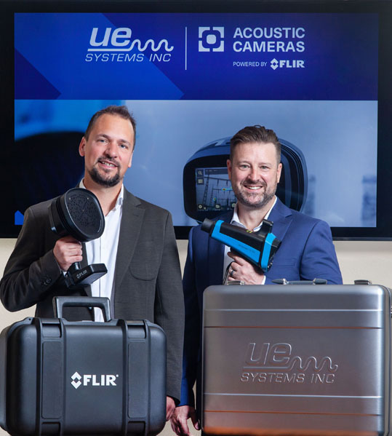](http://www.ablwerbung.de/download/flir/Koen_Jacobs_FLIR_links+Blair_Fraser_UE-Systems_rechts.jpg)